**CS673 Software Engineering** 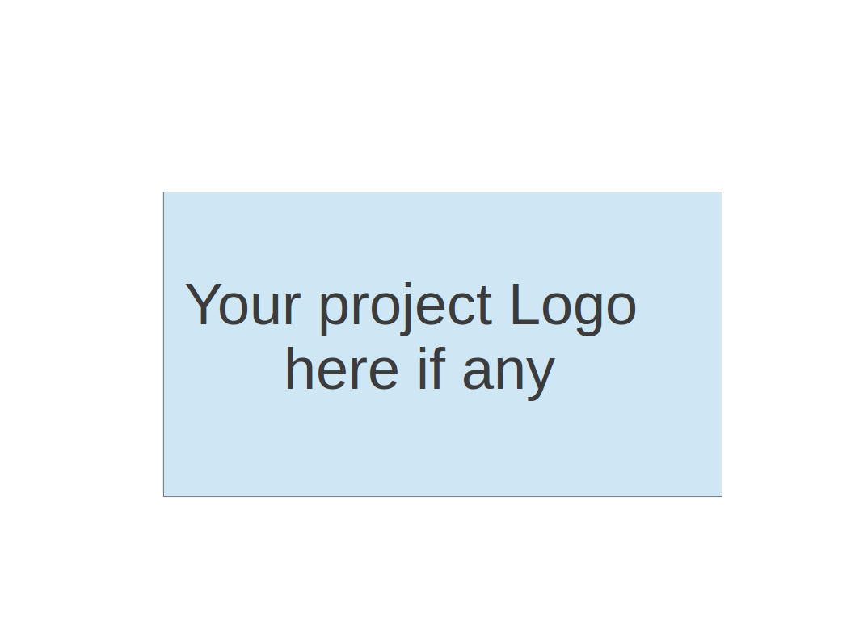

**Team X - Focused Study**

**Software Test Document**

| Team Member | Role(s) | Signature | Date |
| --- | --- | --- | --- |
| Siddhesh Dighe | Team Leader | *Siddhesh* | 11/10/2023 |
| Pushkar | Design Implementation Leader | *Pushkar* | 11/10 /2023 |
| Sai Ramya Devineni | QA Leader | *Ramya* | 11/10 /2023 |
| Ayush Bhaliya | Security Leader | *Ayush* | 11/10 /2023 |
| Paridhi Talwar | Requirement Leader | *Paridhi* | 11/10 /2023 |
| Deepali Chawla | Configuration Leader | *Deepali* | 11/10 /2023 |
| Supriya | Backup QA Leader | *Supriya* | 11/10 /2023 |
|  |  |  |  |

**Revision history**

| **Version** | **Author** | **Date** | **Change** |
| --- | --- | --- | --- |
|  |  |  |  |
|  |  |  |  |

Testing Summary

Manuel Tests Reports

Automated Testing Reports

Testing Metrics

References

Glossary

# Testing Summary

In this section, you will summarise what was tested, who is involved in testing, testing techniques used, and testing result. You may have the following tests

Unit testing

* Every component has been tested
* By each team member
* All test cases are passing

Integration testing

* QA leader is responsible for Integration testing
* Health check added to check integration of backend and frontend
* API tests are in progress, we are continuously testing them. But we decided not to add them to this iteration.

System Testing

* Executed system tests to validate the connectivity between different components.
* It was used to focus on integration
* We were able to integrate and we’re able to connect between different components thus resulting in a successful system test.

Acceptance Testing

* We will perform acceptance testing in the next iteration.

Regression Testing

* We haven’t performed Regression testing yet.

# Manual Testing Report

In our project, we implemented unit tests using Cypress to ensure the robustness and reliability of our application FocusedStudy System.

Our testing covers user interactions and integration for this iteration.We have different web pages that different team members have worked on to implement. For example consider the EducationVideoFeed page , where we write test cases for each and every component. From the search bar , to being able to retrieve the user’s search query followed by checking if the YoutubeAPI is being fetched and the video is being played. Similarly we have written test cases for other components for which you can find it in our repository at this **path : project-cs673f23team2\code\tests\cypress\e2e\ui-tests**

Below is a detailed table of all the pages and its features that we have tested using cypress

| No | Page | Title | Progress |
| --- | --- | --- | --- |
| 1 | Entertainment Feed | 1. User can search for entertainment videos  2. Displays the user's list of hobbies  3. User can filter based on their hobbies for entertainment videos | Finished |
| 2 | Search Page | 1. User profile picture fetched from their Google Account (Default profile image if there is no profile picture on their google account)  2. A label to indicate user\'s name  3. A label to indicate user\'s reward points  4. A textbox to enter topic to learn  5. A "Search" button to search for the mentioned topic  7. Clicking on the search button should navigate the user to the "Browse Videos" page with the mentioned topic  7.1 Clicking on the search button should do nothing if the textbox to enter the topic is empty. | Finished |
| 3 | Sell All Videos | 1. List of videos on the topic from the chosen section  2. Every video from the chosen section must have a thumbnail and info containing title, channel name, date, and views. | Failing |
| 4 | Sign-in Page | 1. A title "Focused Study" with the logo should exist  2. A button should exist with text "Sign-in with Google  3. Clicking the "Sign-in with Google" button should navigate to a new blank page | Finished |
| 5 | User Profile | 1. User profile picture fetched from their Google Account (Default profile image if there is no profile picture on their google account)  2. A label to indicate user\'s name  3. List of all the user hobbies  4. A "List of all the watched videos where each element in the list is has video thumbnail, title and creator name | Finished |
| 6 | Video Details | 1. A label indicating video creator  2. A label indicating video title  3. Video Player should be visible | Failing |
| 7 | Video History | 1. Every video from the video history section must have a thumbnail and info containing title, and watch time  2. Contains "Video History" title | Finished |
| 8 | Onboarding (Hobbies) |  | Pending |

Please find screenshots of the generated testing report for each section:

Updated code(Iteration 3) Tests:

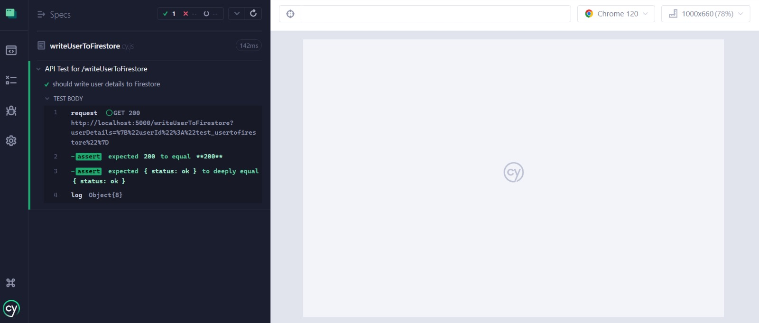

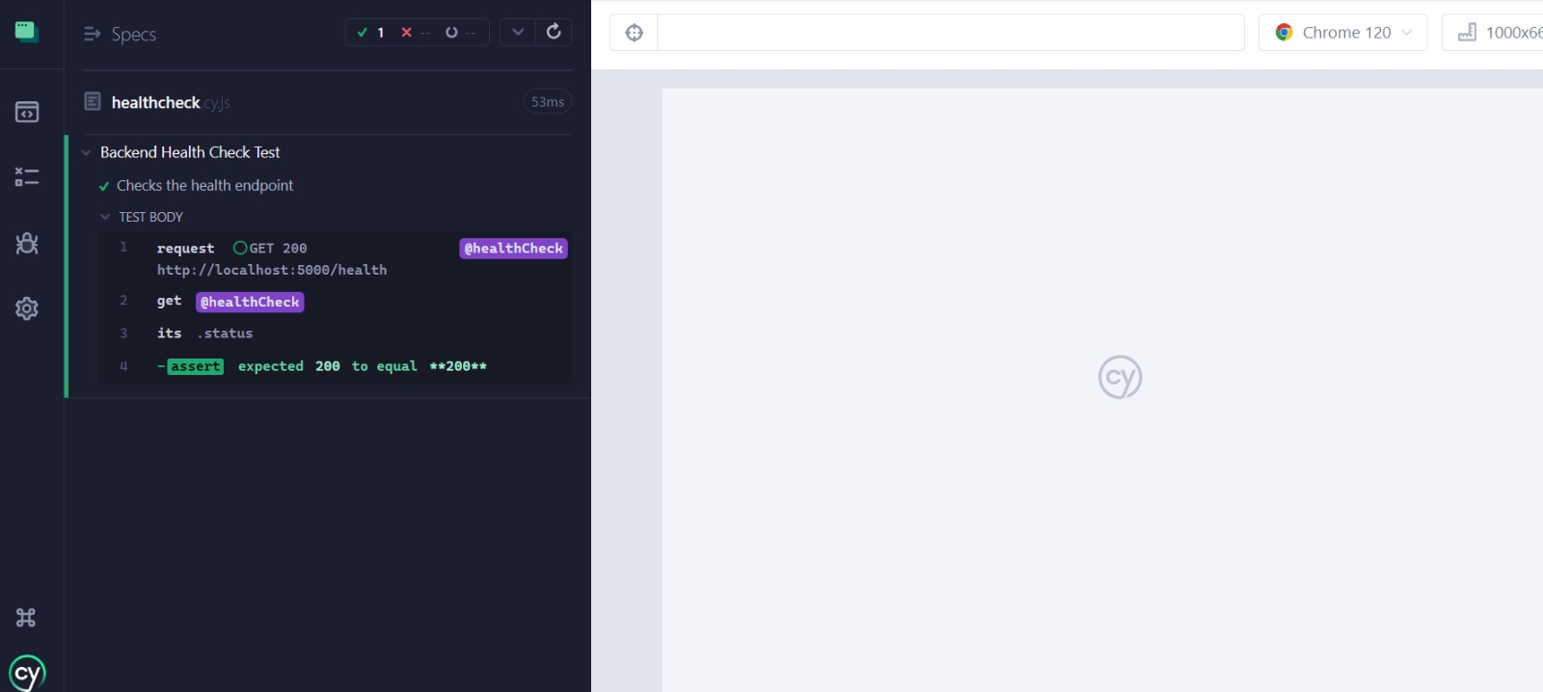

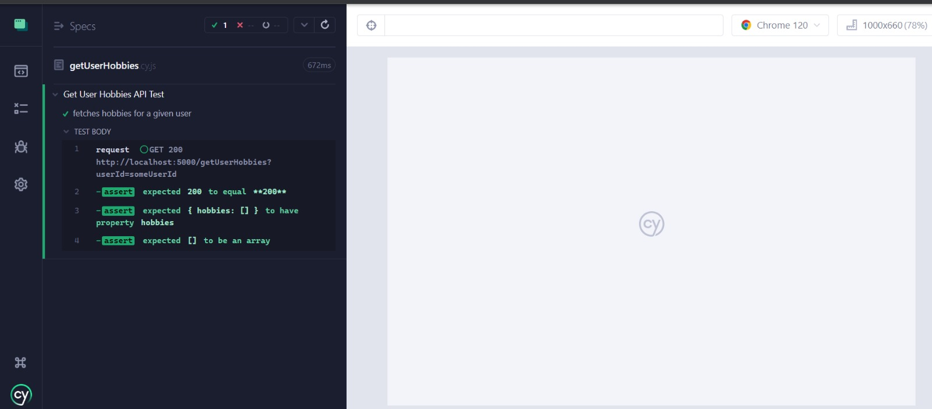

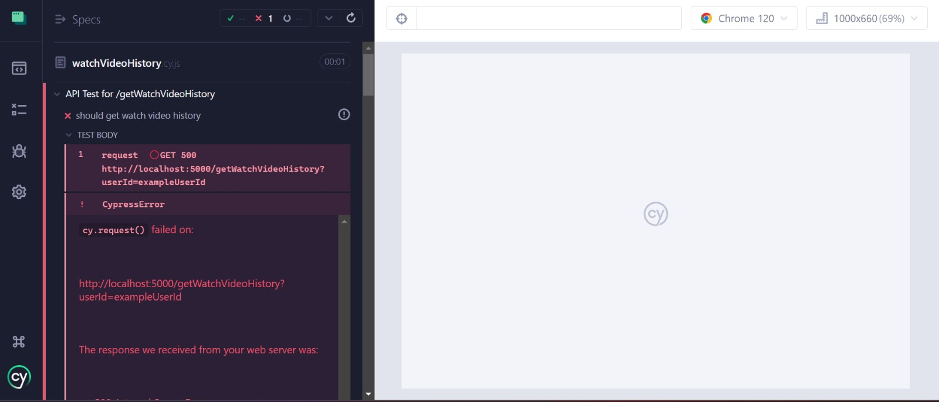

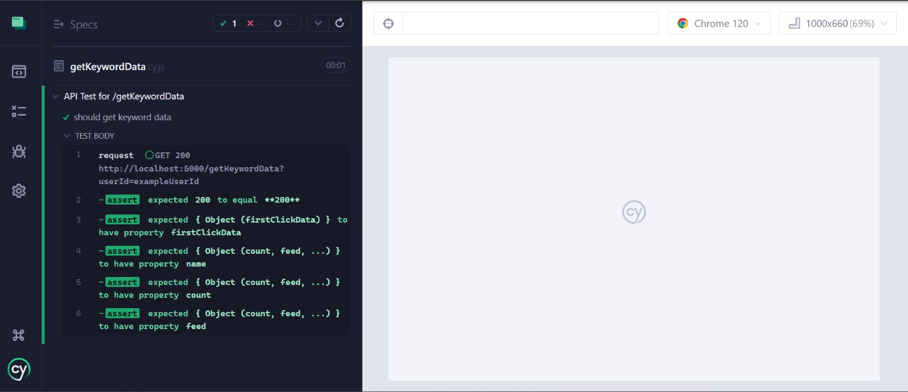

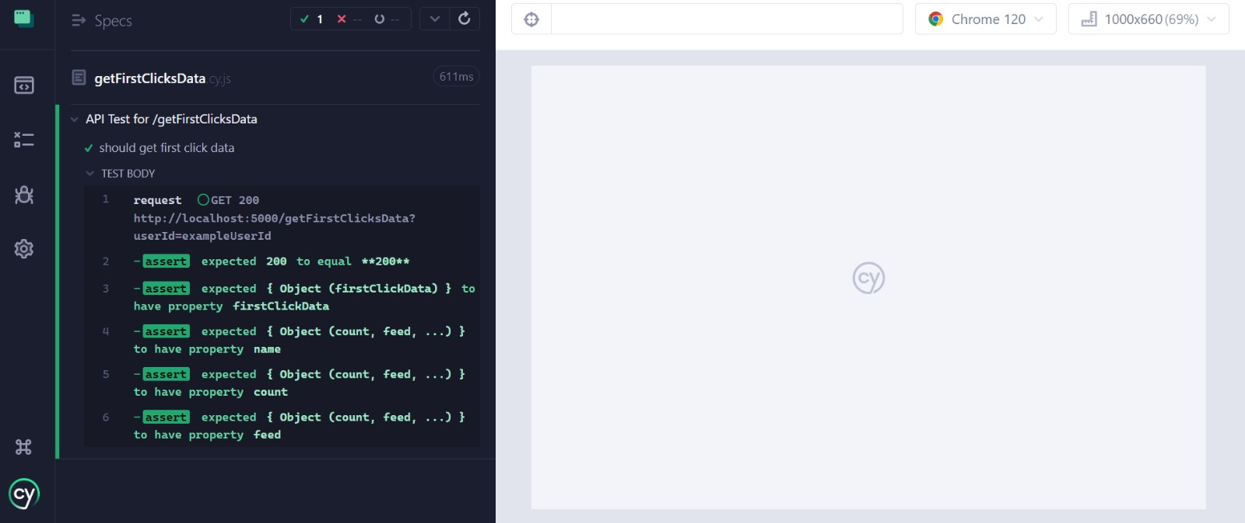

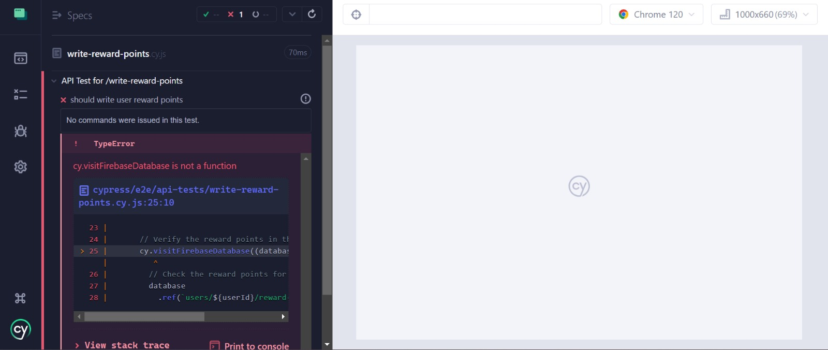

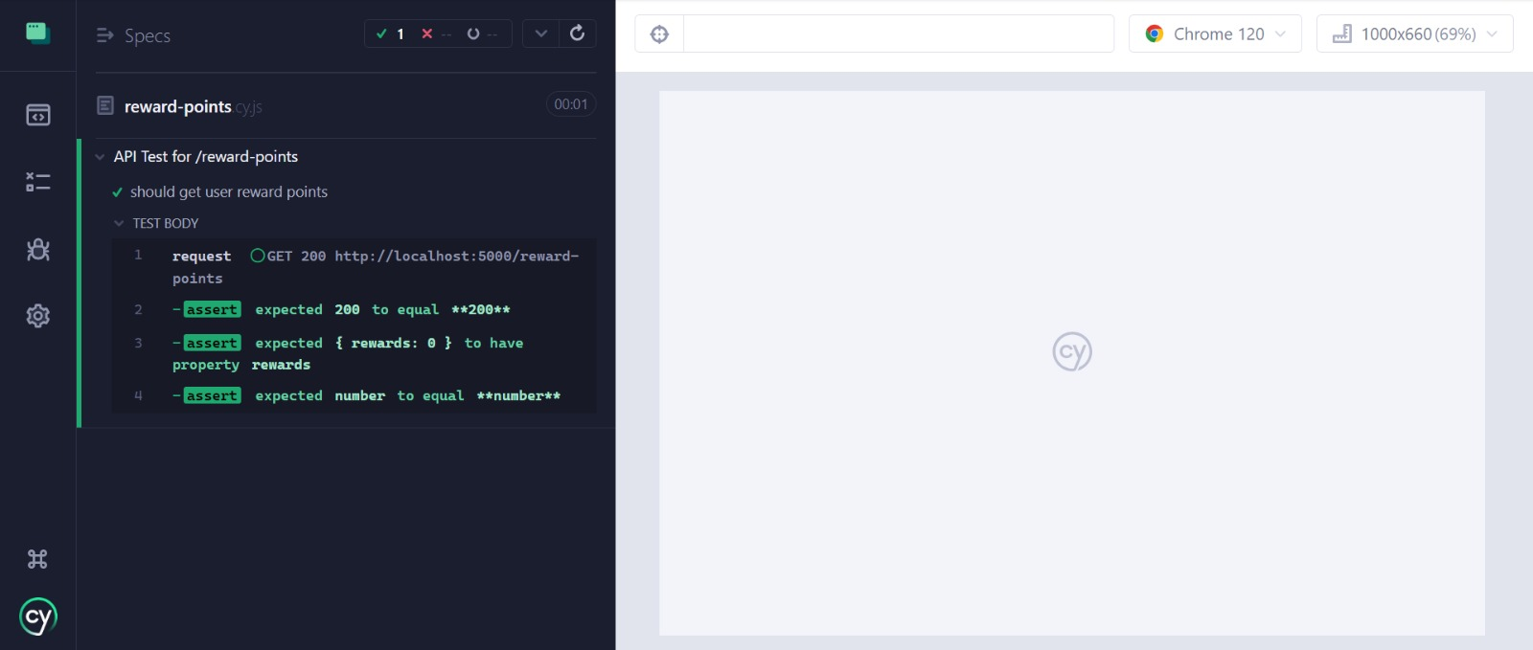

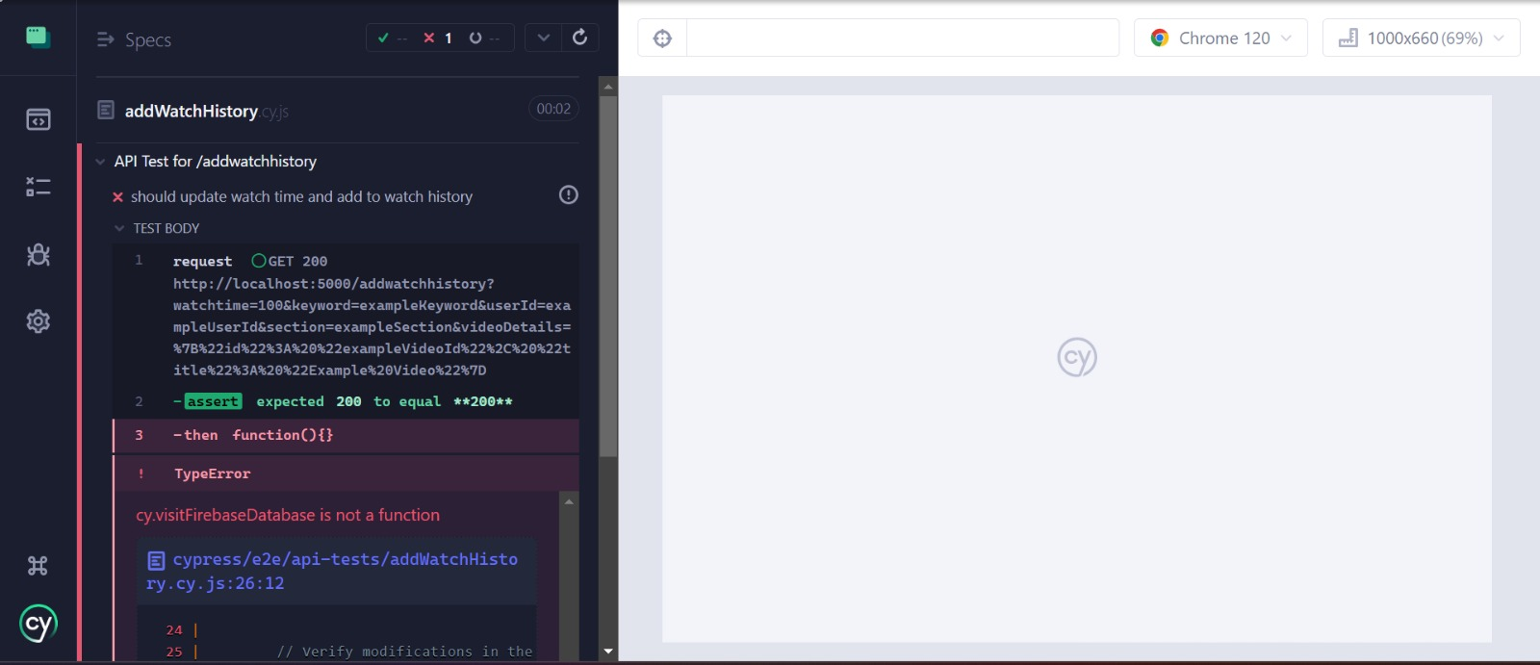

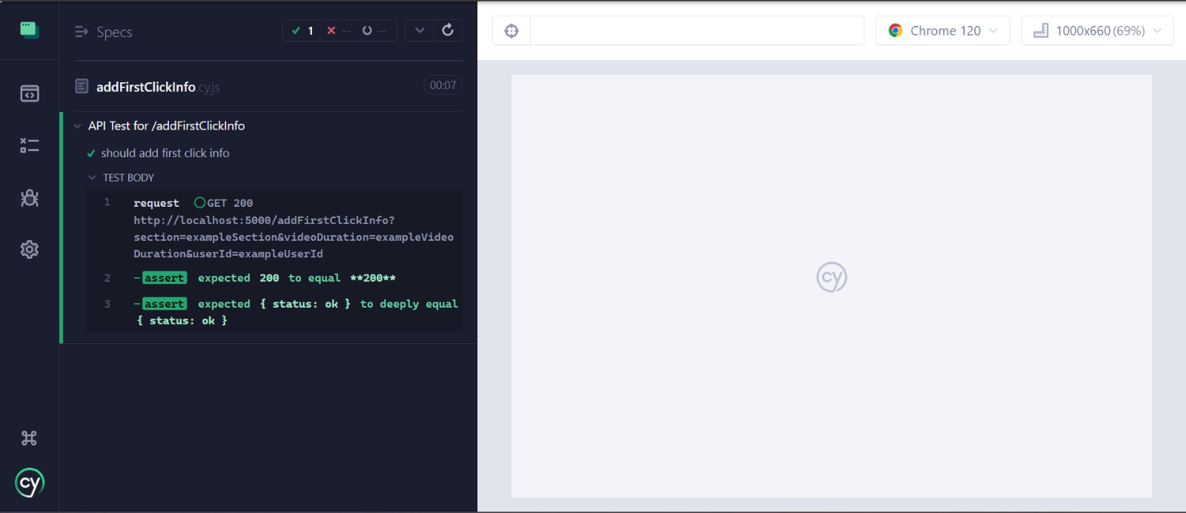

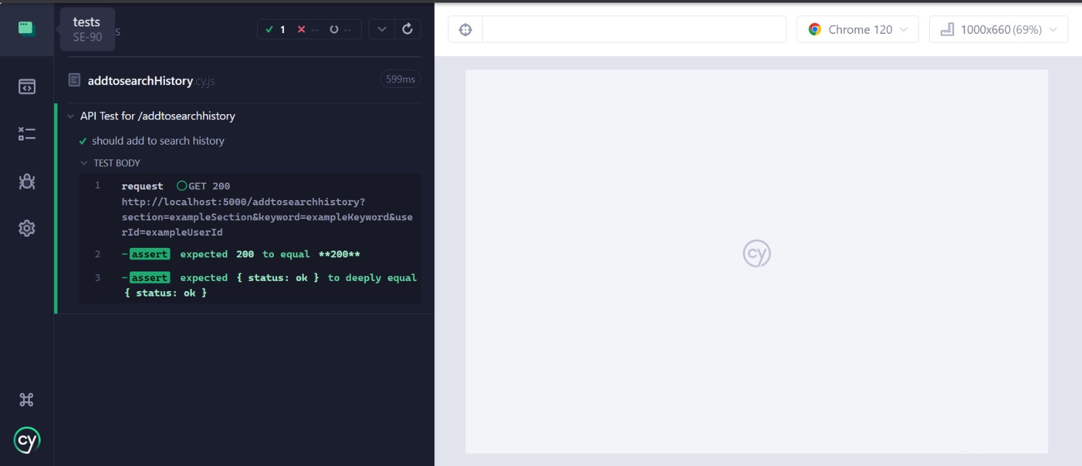

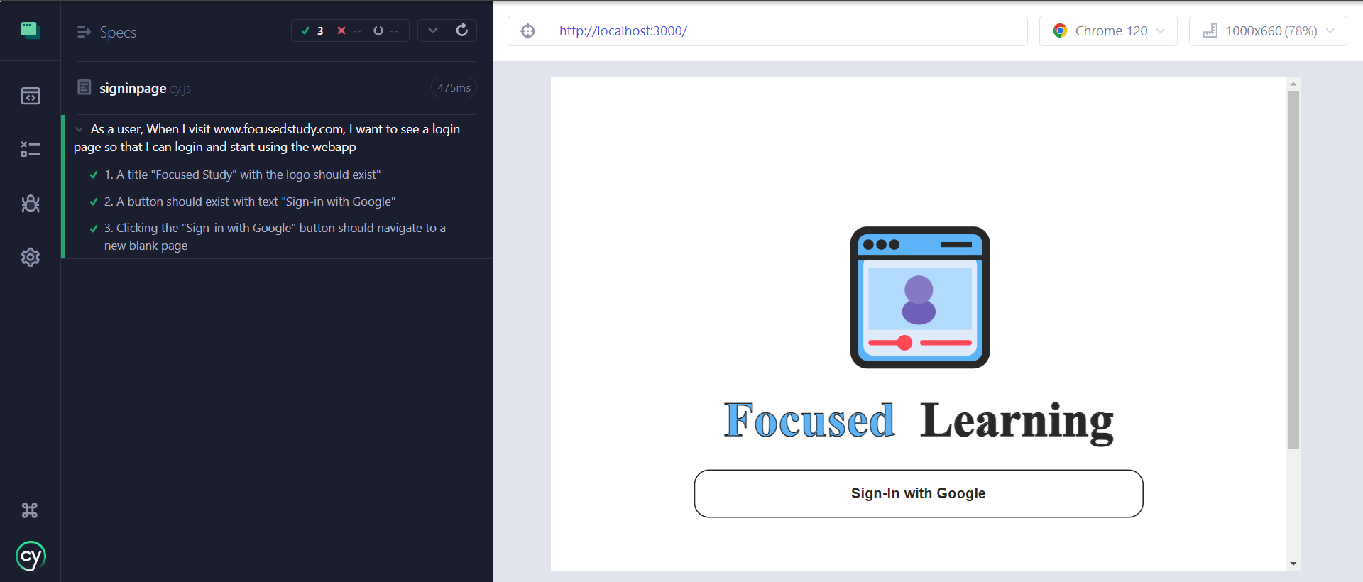

Previous Iteration Tests:

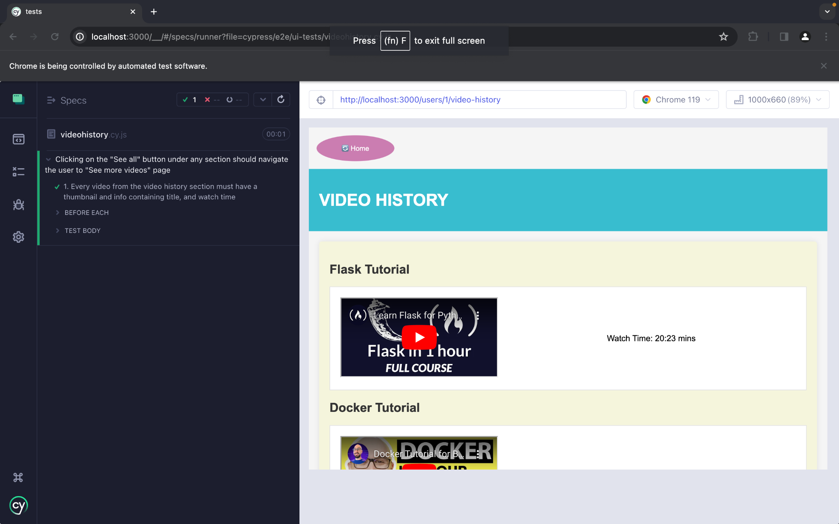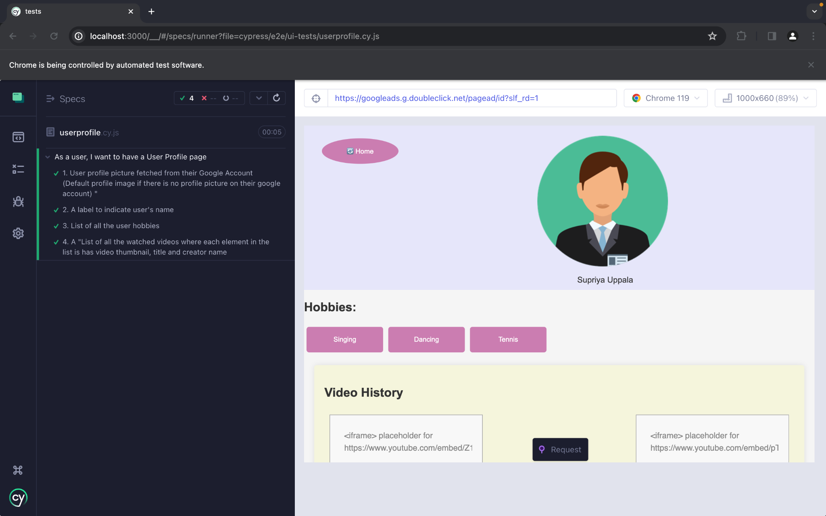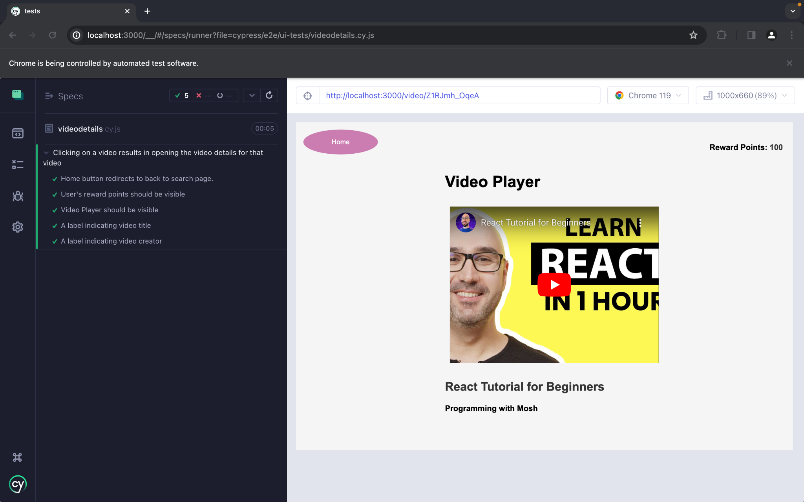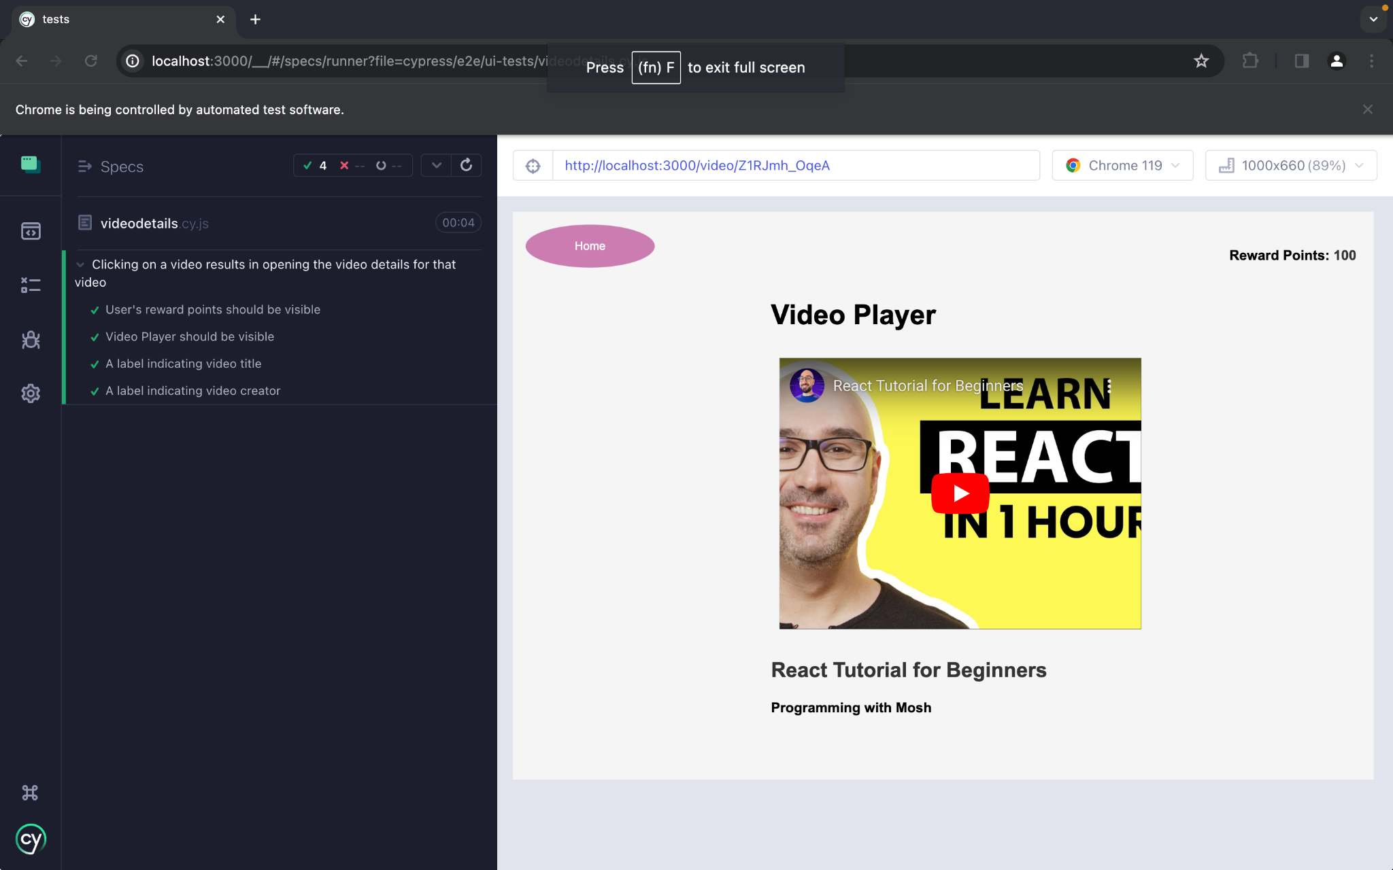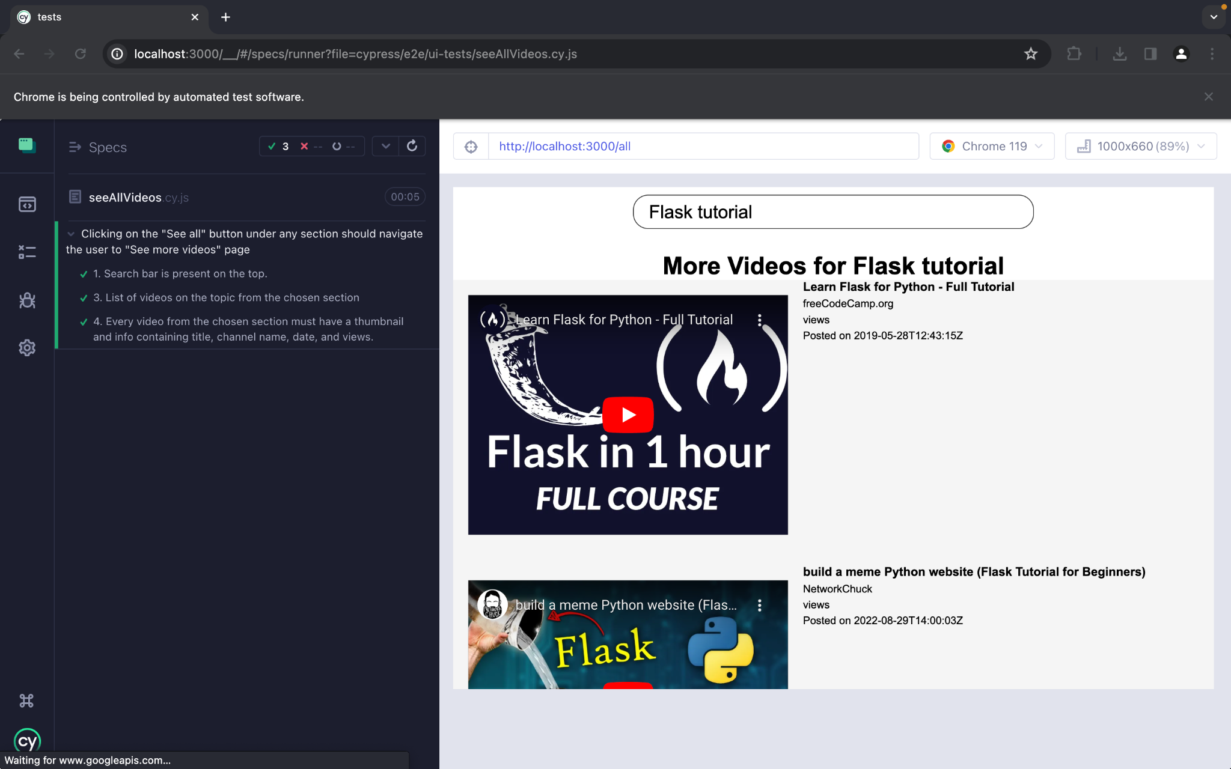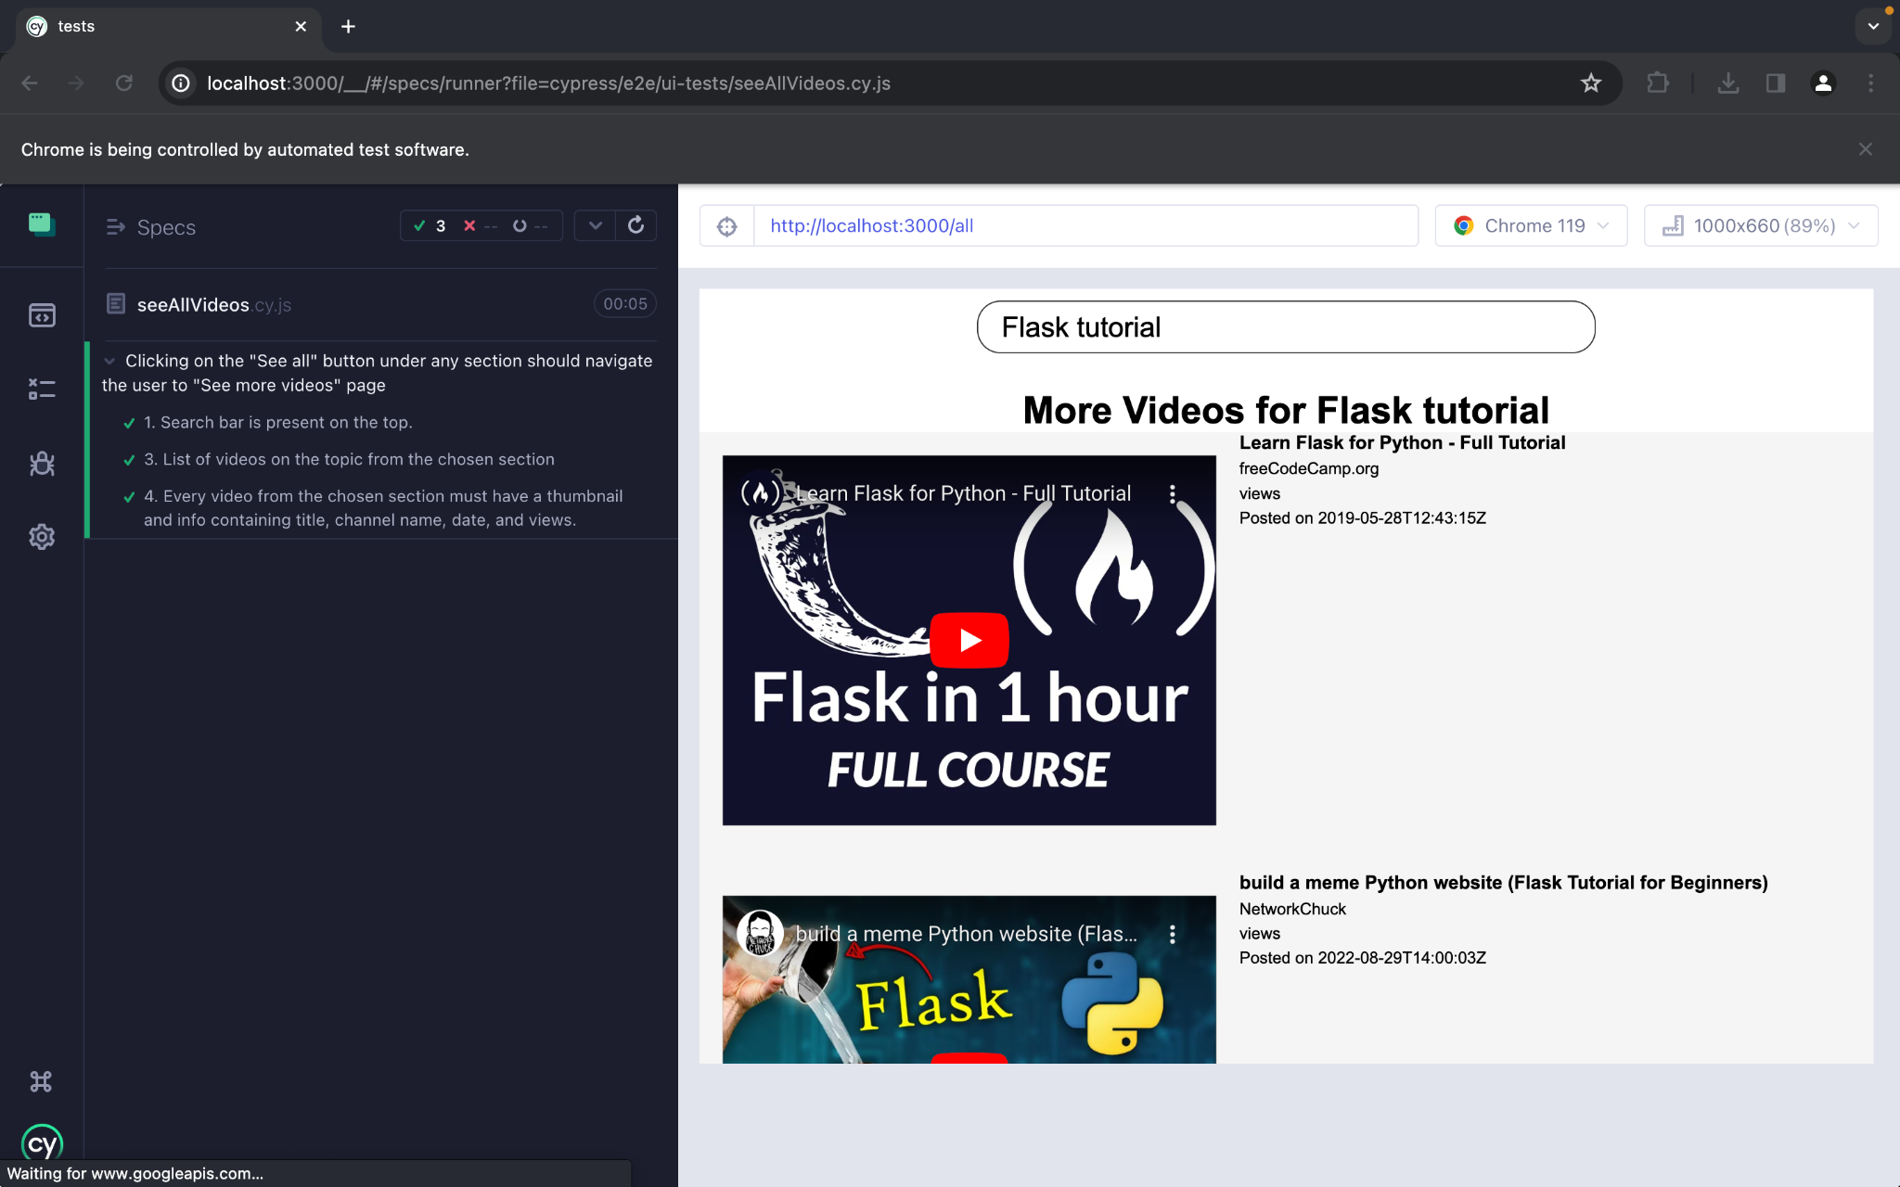

By adopting testing with Cypress, we have enhanced our application's overall quality and established reliable and efficient testing.

# Automated Testing Report

For automated testing, we will be using git actions after we containerised the frontend and backend of our application.

# Testing Metrics

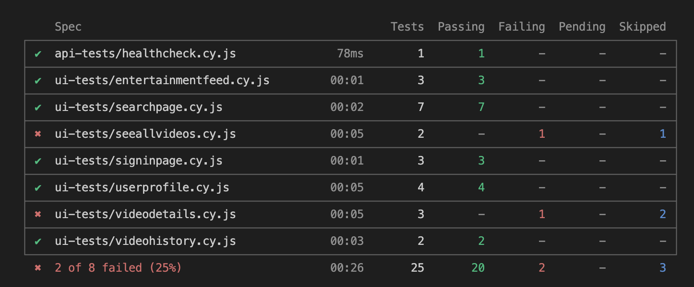

* Currently we have a total of 25 test cases from which 20 test cases are passing, 2 test cases are failing and 3 test cases are being skipped.
* Overall testing success rate is 80%